# **Internet of Things: Assignment 1**

1. **Group Name:** IOTAFCR

Andrew Casey, Fiachra Sheridan,

Cormac Sheridan, Rory Mc Cafferty.

1. **Trello Link:**

<https://trello.com/b/XWCN8cnS>

1. **Team Git-hub Link:**

<https://github.com/AndrewC20/IOT>

1. **Real World Problem Identified:**

We were tasked with finding and solving a problem that we did not know even existed yet. We started with a brainstorming session where we passed a few ideas back and forth to find out what actually sounded like a good idea and would also be fun to attempt to create. Many ideas were passed back and forth, some were simple, some sounded far too complicated. We settled on a few ideas that sounded relatively possible to create and majority vote ruled supreme. We had an idea.

1. **Initial Brainstorming Ideas**

For some students just starting out on an Arduino Yun we were creating some crazy ideas (from remote gun turret drones to sensor alarms that might go off and scare people was the pass an area). We picked our few most realistic and problem-solving ideas we had together to vote on what we should attempt to create.

The list of these included a tone player that could be voice activated that would play fantasy tunes for people that would play Dungeon’s and Dragon’s so for example they would enter a battle and you could call the device to play a dungeon type song which it would look though a list and play one for you.

We had a sensor for your heating when you get home. It could activate in several ways, one being through the internet or just by your phone when you get back it knows your home and could turn on.

We had a few other ideas that just didn’t seem to cut it in the end since we went with the D&D tune player idea. Majority vote rules and most the group played D&D and had fallen in love with the idea.

1. **Final Internet of Things Idea and Solution:**

**Part 1. The music**

Much research was needed to find out how to play music on the Arduino Yun. Google being a good friend we typed in some information like Arduino Yun Music to find out how this device could be used as a glorified monotone epic music player that every good D&D group will need in their arsenal. As coders learning to code, we plan on doing as much of the code as we can but the recourses provided and time restrictions we would need to look up some ideas and codes to get a rough idea of where we are and where we can apply our skill in creating the code for a working prototype.

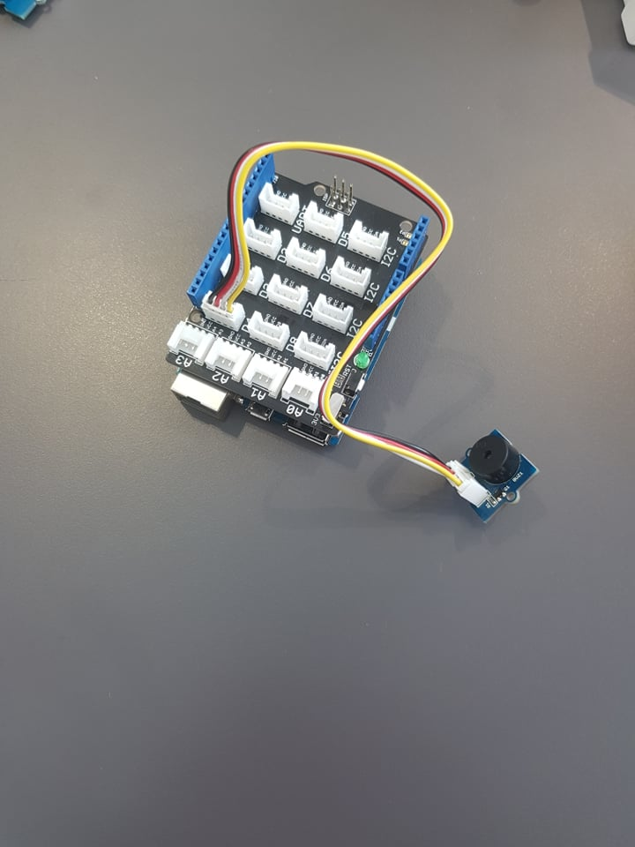

**Part 2. Do we attempt voice activation, or do we go with buttons?**

Researching into voice activation seems to be well beyond a let’s learn first project but does seem to be a subject for future projects, once we are skilled enough to come back to.

Button activation would seem to be the simpler idea.

A next/back button and at least one more button to start/stop so at the least three buttons would be required with possibly a few more for other functions if they are required and we have the resources/time to do so.

**Part 3. A screen for navigation would be needed**

We would need an LCD screen to show what song we are on and where we go next, what is playing etc.

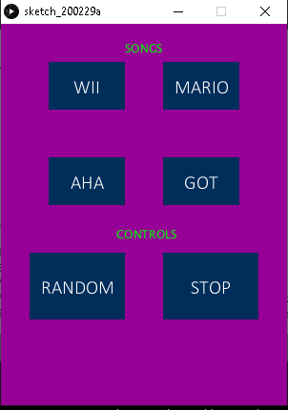

We used Processing 3 to make an interface/app to control the arduino yun, similer to an mp3 player.

1. **Potential future development ideas.**

Starting as a useful device that could be used in ex. D&D. For a group of people to enhance their fantasy roleplay experience with music that would make them feel more involved in the game as they play to what could be used as a type of device that we could say “Device, play me some of my favorite band songs for me “ and the device could look for your favorite band and pick a few of the ex. Greatest hits.

The device could also be set up that music could play as you enter your house when your phone is in proximity and you example have toggled a (yes I want music on as I get home) button or app on your phone.

Setting a starting point on coding and using devices like Arduino Yun to add devices locally and wirelessly the idea of what we can create and where we can go expands almost indefinitely.

This could be expanded on to be useful for any home appliance.

1. **Technical, team, and other problems encountered**

Some of the problems we encountered:

* Starting on a new device and working out what you want to do and what you can do with the resources you have.
* One of the main problems we had was working with new programming languages. We used C in Arduino and JAVA in Processing 3.
* We had a lot of trouble finding code for the music we wanted to use. We eventually found a library of code that had multiple songs, ranging from game theme songs, to classical music, to pop culture.